1. To draw line charts of employees where hire date between JAN- 2013 to DEC-2020

Ans:

import pandas as pd

import matplotlib.pyplot as plt

data = {

'ID': [1, 2, 3, 4, 5],

'Hire Date': ['2013-05-15', '2014-06-20', '2015-07-30', '2016-08-10', '2020-12-25']

}

df = pd.DataFrame(data)

df['Hire Date'] = pd.to_datetime(df['Hire Date'])

filtered_df = df[(df['Hire Date'] >= '2013-01-01') & (df['Hire Date'] <= '2020-12-31')]

filtered_df['Year'] = filtered_df['Hire Date'].dt.year

hire_counts = filtered_df['Year'].value_counts().sort_index()

plt.plot(hire_counts.index, hire_counts.values, marker='o')

plt.title('Employee Hires from 2013 to 2020')

plt.xlabel('Year')

plt.ylabel('Number of Hires')

plt.xticks(hire_counts.index)

plt.grid()

plt.show()

output:-

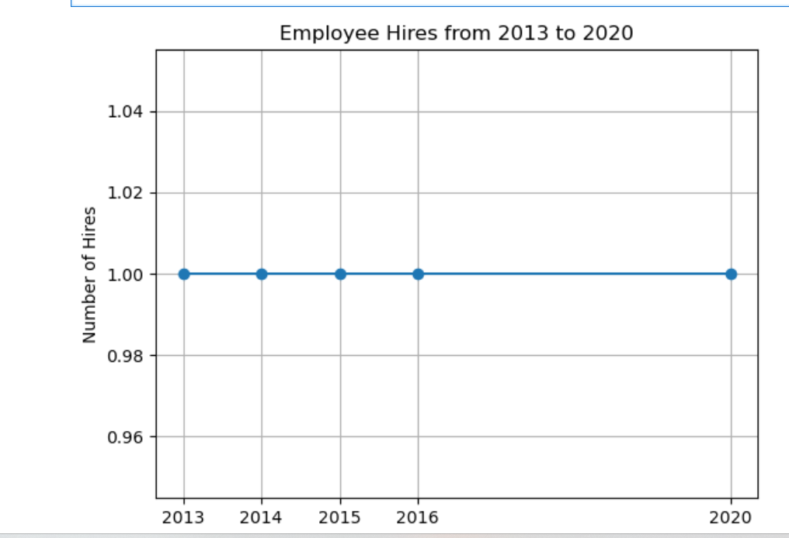

1. To display a bar chart of the popularity of programming Languages. Use different colour for each bar. Programming languages: Java, Python, PHP, JavaScript, C#, C++ Popularity: 24.2, 19.3, 9.8, 8.5, 7.3, 6.2

Ans:

import matplotlib.pyplot as plt

languages = ['Java', 'Python', 'PHP', 'JavaScript', 'C#', 'C++']

popularity = [24.2, 19.3, 9.8, 8.5, 7.3, 6.2]

colors = ['#FF5733', '#33FF57', '#3357FF', '#F1C40F', '#9B59B6', '#E74C3C']

plt.figure(figsize=(10, 6))

plt.bar(languages, popularity, color=colors)

plt.title('Popularity of Programming Languages')

plt.xlabel('Programming Languages')

plt.ylabel('Popularity (%)')

plt.xticks(rotation=45)

plt.tight_layout()

plt.show()

OP:

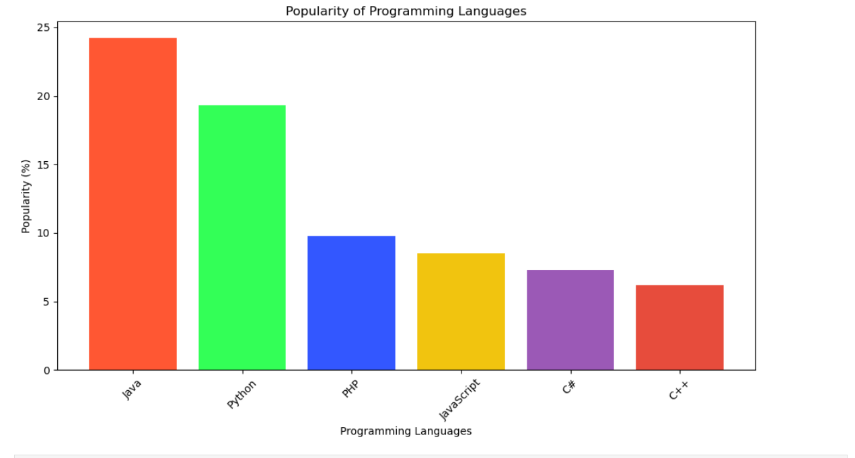

1. To create a pie chart of the popularity of programming Languages.

Ans:

import matplotlib.pyplot as plt

languages = ['Java', 'Python', 'PHP', 'JavaScript', 'C#', 'C++']

popularity = [24.2, 19.3, 9.8, 8.5, 7.3, 6.2]

plt.figure(figsize=(8, 8))

plt.pie(popularity, labels=languages, autopct='%1.1f%%', startangle=140)

plt.title('Popularity of Programming Languages')

plt.axis('equal')

plt.show()

OP: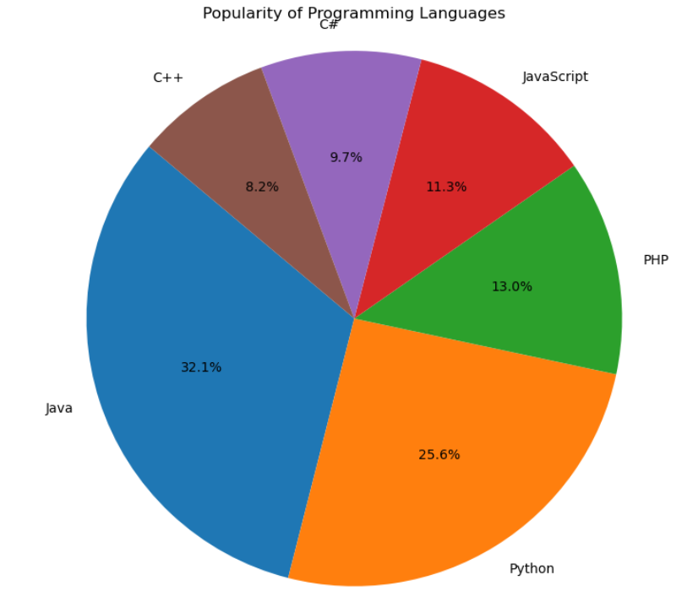

1. To create a stacked bar plot with error bars. Use bottom to stack the womens bars on top of the bar men’s. Means (men) = (22, 30, 35, 35, 26) Means (women) = (25, 32, 30, 35, 29) Men Standard deviation = (4, 3, 4, 1, 5) Women Standard deviation = (3, 5, 2, 3, 3)

Ans:

import matplotlib.pyplot as plt

import numpy as np

categories = ['A', 'B', 'C', 'D', 'E']

men_means = [22, 30, 35, 35, 26]

women_means = [25, 32, 30, 35, 29]

men_std = [4, 3, 4, 1, 5]

women_std = [3, 5, 2, 3, 3]

x = np.arange(len(categories))

bar_width = 0.4

plt.bar(x, men_means, yerr=men_std, width=bar_width, label='Men', color='lightblue', capsize=5)

plt.bar(x, women_means, yerr=women_std, bottom=men_means, width=bar_width, label='Women', color='lightcoral', capsize=5)

plt.xlabel('Categories')

plt.ylabel('Means')

plt.title('Stacked Bar Plot with Error Bars')

plt.xticks(x, categories)

plt.legend()

plt.tight_layout()

plt.show()

OP:

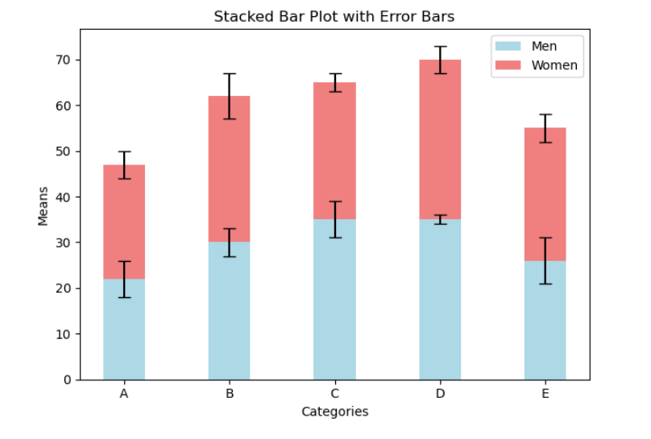

1. To draw a scatter plot comparing two subject marks of Mathematics and Science. Use marks of 10 students. Data: math_marks = [88, 92, 80, 89, 100, 80, 60, 100, 80, 34] science_marks = [35, 79, 79, 48, 100, 88, 32, 45, 20, 30] marks_range = [10, 20, 30, 40, 50, 60, 70, 80, 90, 100]

Ans:

import matplotlib.pyplot as plt

math_marks = [88, 92, 80, 89, 100, 80, 60, 100, 80, 34]

science_marks = [35, 79, 79, 48, 100, 88, 32, 45, 20, 30]

marks_range = [10, 20, 30, 40, 50, 60, 70, 80, 90, 100]

plt.figure(figsize=(8, 6))

plt.scatter(math_marks, science_marks, color='blue')

plt.xlabel('Mathematics Marks')

plt.ylabel('Science Marks')

plt.title('Scatter Plot of Mathematics vs Science Marks')

plt.xlim(0, 110)

plt.ylim(0, 110)

plt.grid(True)

plt.axhline(50, color='red', linestyle='--')

plt.axvline(50, color='red', linestyle='--')

plt.show()

OP:

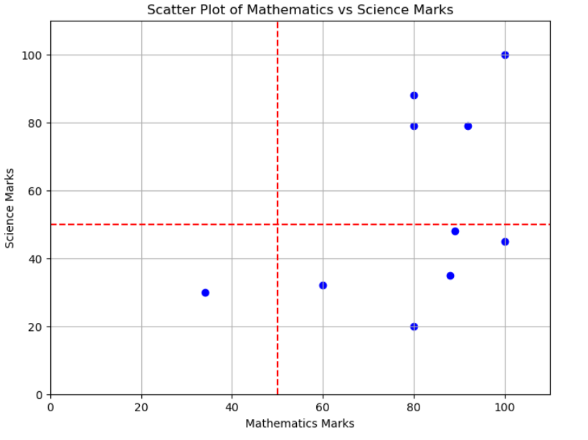

1. Solve some following questions based on below table. Get total profit of all months and show line plot with the following Style properties • Line Style dotted and Line-color should be red • Show legend at the lower right location. • X label name = Month Number • Y label name = Sold units number • Add a circle marker. • Line marker color as read

• Line width should be 3

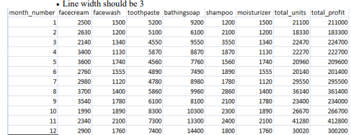

Ans:

import matplotlib.pyplot as plt

month_number = [1, 2, 3, 4, 5, 6, 7, 8, 9, 10, 11, 12]

total_profit = [211000, 183300, 224700, 222700, 209600, 201400, 295500, 312000, 234000, 266700, 412800, 300200]

plt.figure(figsize=(10, 6))

plt.plot(month_number, total_profit, linestyle=':', color='red', marker='o', markersize=8,

markerfacecolor='red', linewidth=3, label='Total Profit')

plt.xlabel('Month Number')

plt.ylabel('Total Profit')

plt.title('Total Profit per Month')

plt.legend(loc='lower right')

plt.grid(True)

plt.show()

OP:

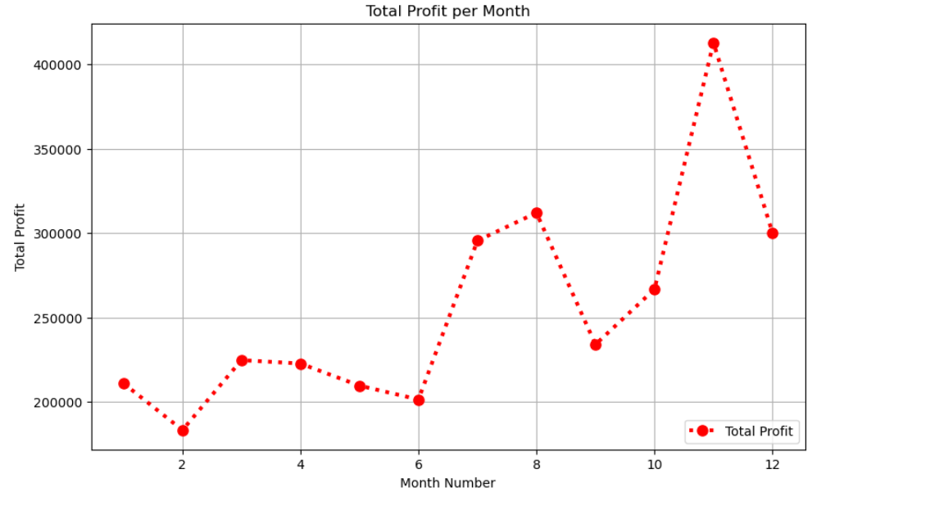

1. Draw scatter plot of toothpaste sales data of each month

Ans:

toothpaste_sales = [5200, 5100, 4550, 5870, 4560, 7490, 4780, 5860, 6110, 10300, 8300, 7400]

plt.figure(figsize=(10, 6))

plt.scatter(month_number, toothpaste_sales, color='blue', s=100, label='Toothpaste Sales')

plt.xlabel('Month Number')

plt.ylabel('Toothpaste Sales')

plt.title('Toothpaste Sales per Month')

plt.legend()

plt.grid(True)

plt.show()

OP:

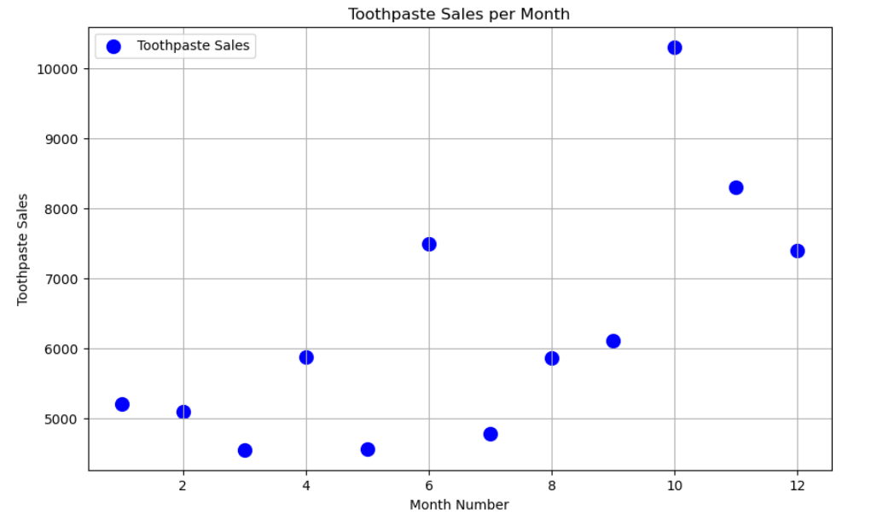

1. Construct histogram of most common profit ranges of the total profit of each month.

Ans:

# Create a histogram of total profits

plt.figure(figsize=(10, 6))

plt.hist(total_profit, bins=5, color='green', edgecolor='black', alpha=0.7)

# Add labels and title

plt.xlabel('Total Profit Ranges')

plt.ylabel('Frequency')

plt.title('Histogram of Total Profit Ranges per Month')

# Display the histogram

plt.grid(True)

plt.show()

OP:

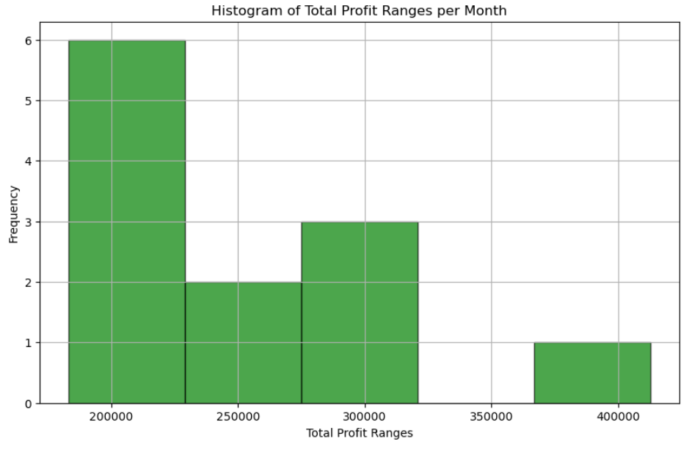

1. Draw Pie chart calculate total sale data for last year for each product.

Ans:

facecream_sales = [2500, 2630, 2140, 3400, 3150, 2760, 2980, 3700, 3540, 1990, 2340, 2900]

facewash_sales = [1500, 1200, 1340, 1130, 1555, 1555, 1120, 2140, 1780, 1890, 1760, 1760]

toothpaste_sales = [5200, 5100, 4550, 5870, 4560, 7490, 4780, 5860, 6110, 10300, 8300, 7400]

bathingsoap_sales = [9200, 6100, 9550, 8870, 7760, 7490, 8980, 9960, 8110, 10300, 13300, 14400]

shampoo_sales = [1200, 2100, 3550, 1870, 1560, 1740, 1780, 2860, 2110, 2300, 2400, 1800]

moisturizer_sales = [1500, 1200, 1340, 1870, 1560, 1740, 1120, 2090, 1780, 1890, 2100, 1760]

total_sales = [

sum(facecream_sales),

sum(facewash_sales),

sum(toothpaste_sales),

sum(bathingsoap_sales),

sum(shampoo_sales),

sum(moisturizer_sales)

]

products = ['Facecream', 'Facewash', 'Toothpaste', 'Bathing Soap', 'Shampoo', 'Moisturizer']

plt.figure(figsize=(8, 8))

plt.pie(total_sales, labels=products, autopct='%1.1f%%', startangle=140, colors=['gold', 'lightblue', 'lightgreen', 'coral', 'pink', 'violet'])

plt.title('Total Sales Data for Last Year by Product')

plt.show()

OP:

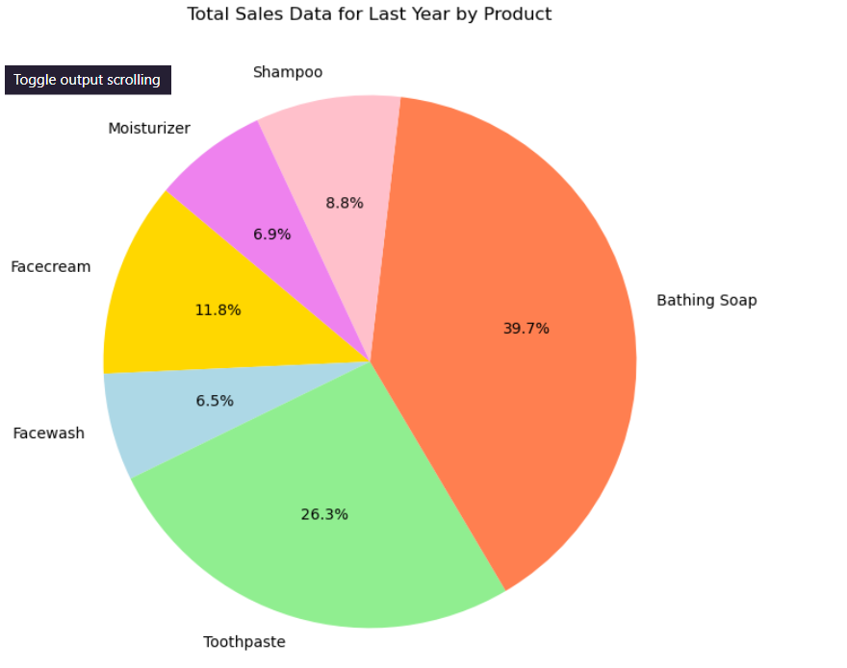

1. Draw stack plot of all product sales data.

Ans:

import matplotlib.pyplot as plt

month_number = [1, 2, 3, 4, 5, 6, 7, 8, 9, 10, 11, 12]

facecream_sales = [2500, 2630, 2140, 3400, 3150, 2760, 2980, 3700, 3540, 1990, 2340, 2900]

facewash_sales = [1500, 1200, 1340, 1130, 1555, 1555, 1120, 2140, 1780, 1890, 1760, 1760]

toothpaste_sales = [5200, 5100, 4550, 5870, 4560, 7490, 4780, 5860, 6110, 10300, 8300, 7400]

bathingsoap_sales = [9200, 6100, 9550, 8870, 7760, 7490, 8980, 9960, 8110, 10300, 13300, 14400]

shampoo_sales = [1200, 2100, 3550, 1870, 1560, 1740, 1780, 2860, 2110, 2300, 2400, 1800]

moisturizer_sales = [1500, 1200, 1340, 1870, 1560, 1740, 1120, 2090, 1780, 1890, 2100, 1760]

plt.figure(figsize=(10, 6))

plt.stackplot(month_number, facecream_sales, facewash_sales, toothpaste_sales, bathingsoap_sales,

shampoo_sales, moisturizer_sales, labels=['Facecream', 'Facewash', 'Toothpaste', 'Bathing Soap', 'Shampoo', 'Moisturizer'], colors=['gold', 'lightblue', 'lightgreen', 'coral', 'pink', 'violet'])

plt.xlabel('Month Number')

plt.ylabel('Sales')

plt.title('Stack Plot of Product Sales Data')

plt.legend(loc='upper left')

plt.show()

OP:

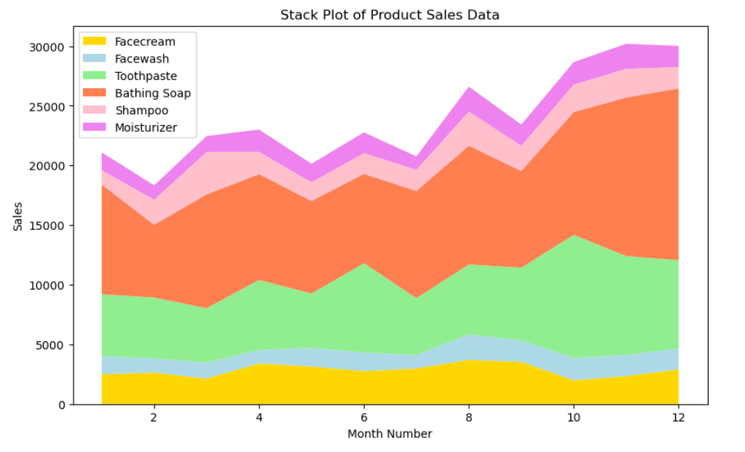

1. Construct Subplot of Bathing soap face wash of all months

Ans:

import matplotlib.pyplot as plt

month_number = [1, 2, 3, 4, 5, 6, 7, 8, 9, 10, 11, 12]

bathingsoap_sales = [9200, 6100, 9550, 8870, 7760, 7490, 8980, 9960, 8110, 10300, 13300, 14400]

facewash_sales = [1500, 1200, 1340, 1130, 1555, 1555, 1120, 2140, 1780, 1890, 1760, 1760]

fig, (ax1, ax2) = plt.subplots(1, 2, figsize=(12, 6))

ax1.plot(month_number, bathingsoap_sales, color='orange', marker='o')

ax1.set_title('Bathing Soap Sales per Month')

ax1.set_xlabel('Month Number')

ax1.set_ylabel('Sales')

ax1.grid(True)

ax2.plot(month_number, facewash_sales, color='blue', marker='o')

ax2.set_title('Face Wash Sales per Month')

ax2.set_xlabel('Month Number')

ax2.set_ylabel('Sales')

ax2.grid(True)

plt.tight_layout()

plt.show()

OP:

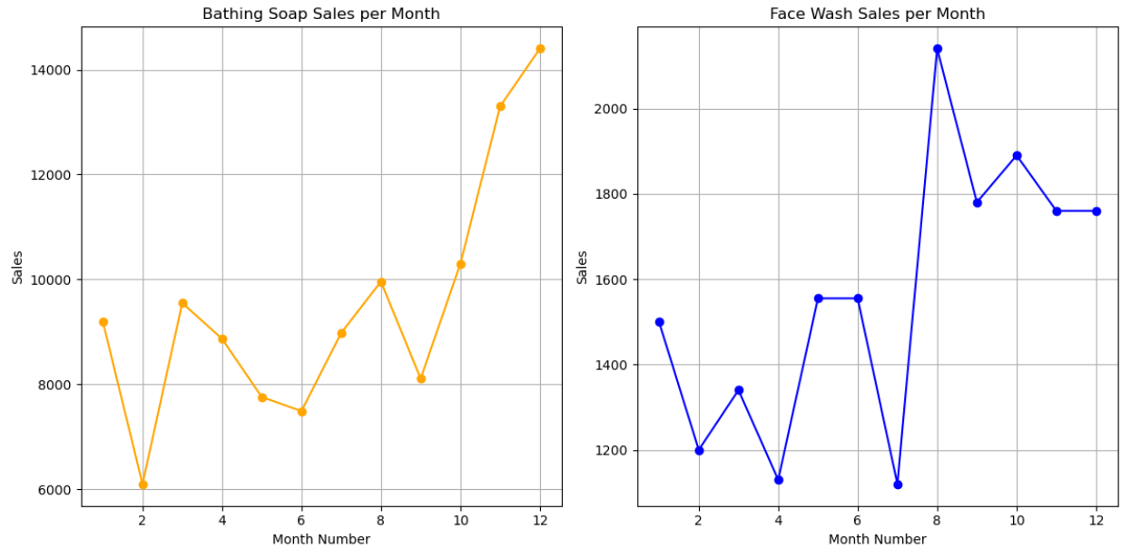

1. Draw box plot and violin plot.

Ans:

import matplotlib.pyplot as plt

products = ['Facecream', 'Facewash', 'Toothpaste', 'Bathing Soap', 'Shampoo', 'Moisturizer']

facecream_sales = [2500, 2630, 2140, 3400, 3150, 2760, 2980, 3700, 3540, 1990, 2340, 2900]

facewash_sales = [1500, 1200, 1340, 1130, 1555, 1555, 1120, 2140, 1780, 1890, 1760, 1760]

toothpaste_sales = [5200, 5100, 4550, 5870, 4560, 7490, 4780, 5860, 6110, 10300, 8300, 7400]

bathingsoap_sales = [9200, 6100, 9550, 8870, 7760, 7490, 8980, 9960, 8110, 10300, 13300, 14400]

shampoo_sales = [1200, 2100, 3550, 1870, 1560, 1740, 1780, 2860, 2110, 2300, 2400, 1800]

moisturizer_sales = [1500, 1200, 1340, 1870, 1560, 1740, 1120, 2090, 1780, 1890, 2100, 1760]

sales_data = [facecream_sales, facewash_sales, toothpaste_sales, bathingsoap_sales, shampoo_sales, moisturizer_sales]

plt.figure(figsize=(12, 6))

plt.subplot(1, 2, 1)

plt.boxplot(sales_data, labels=products)

plt.title('Box Plot of Product Sales Data')

plt.xlabel('Products')

plt.ylabel('Sales')

plt.subplot(1, 2, 2)

plt.violinplot(sales_data, showmeans=False, showmedians=True)

plt.title('Violin Plot of Product Sales Data')

plt.xticks([1, 2, 3, 4, 5, 6], products) # Setting x-ticks to match the product labels

plt.xlabel('Products')

plt.ylabel('Sales')

plt.tight_layout()

plt.show()

OP:

